In order to ensure a systematic and comprehensive approach to the development of the innovative coffee and ‘selit’ exporting system, a well-structured Work Breakdown Structure (WBS) has been devised. This WBS serves as a foundational framework, delineating the key tasks and activities essential for the successful implementation of the system. By breaking down the project into manageable components, this structure facilitates a clear understanding of the project's scope and enables efficient planning, execution, and monitoring of tasks at each stage. The following WBS outlines the hierarchical decomposition of the project phases, providing a structured overview of the various tasks and their interdependencies in the journey toward establishing a seamless and transparent coffee and ‘selit’ exporting system.

1. **Requirement Analysis Phase**
   * Identify key stakeholders
   * Gather requirements from exporters and farmers
   * Analyze challenges in the coffee and ‘selit’ exporting system
2. **System Design Phase**
   * Design user interface for exporters and farmers
   * Develop farmer exporter bridging system architecture
   * Determine data structures and protocols for transactions
3. **Development Phase**
   * Implement the farmer exporter bridging system infrastructure
   * Integrate secure transaction protocols
   * Create user-friendly (specially farmer friendly) interface for the system
   * Conduct testing and debugging for the system
4. **Deployment Phase**
   * Plan the system deployment strategy
   * Execute the deployment plan
   * Conduct a pilot test for the system
5. **Training and Support Phase**
   * Provide comprehensive training for system users
   * Establish a support system for users
6. **Evaluation and Improvement Phase**
   * Collect feedback from stakeholders
   * Analyze the system's performance
   * Identify areas for system improvement
   * Implement necessary updates and upgrades

**Gantt Chart**

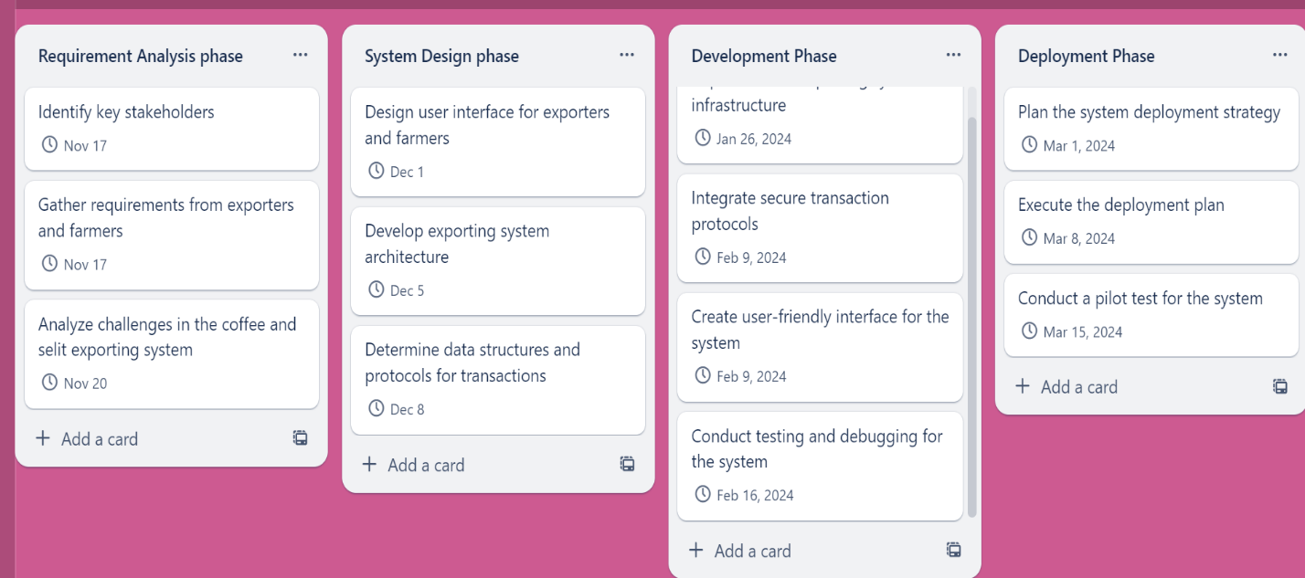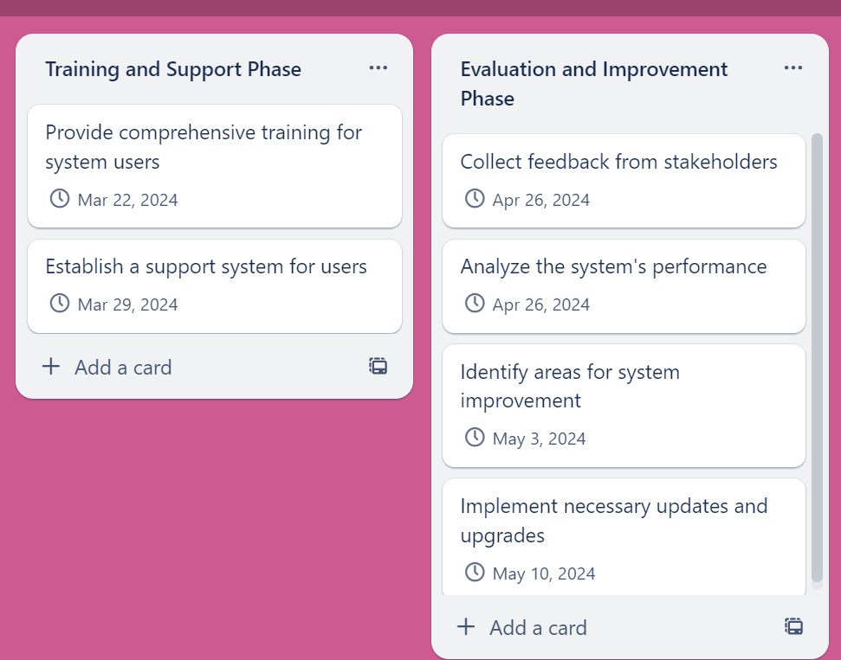

<https://trello.com/invite/b/5izQbpTp/ATTI1ad4a3eeeaec3ff80eabf4b5ad617c5aE93DFE93/farmex>

Efficient project scheduling is crucial for the successful execution of our mission to establish a groundbreaking system that fosters direct interaction between exporters and farmers in the coffee and ‘selit’ exporting system. With the aim of eliminating intermediaries and enhancing the efficiency of the export process, our project endeavors to revolutionize the coffee and ‘selit’ export industry. By strategically organizing and managing the tasks involved, we can ensure a streamlined development process that adheres to set timelines and guarantees the timely delivery of a robust, user-friendly, and transparent system. This project scheduling plan serves as a roadmap, outlining the key phases and tasks crucial to the realization of our vision.

1. **Research and Requirement Analysis Phase (2 weeks)**
   * Identify key stakeholders (exporters, farmers, regulatory authorities)
   * Gather requirements from both exporters and farmers
   * Analyze the existing challenges and pain points in the supply chain
   * Define the scope and objectives of the system
2. **System Design Phase (3 weeks)**
   * Create a detailed system architecture for the blockchain-based platform
   * Design the user interface for exporters and farmers
   * Determine the data structures and protocols for secure transactions
   * Establish protocols for quality control and verification
3. **Development Phase (8 weeks)**
   * Set up the blockchain infrastructure for the coffee supply chain
   * Implement smart contracts for transparent and secure transactions
   * Develop a user-friendly interface for both exporters and farmers
   * Integrate quality control mechanisms into the system
   * Conduct rigorous testing and debugging to ensure the system's robustness
4. **Deployment Phase (2 weeks)**
   * Plan and execute the deployment strategy for the system
   * Conduct a pilot test with a select group of exporters and farmers
   * Collect feedback and make necessary adjustments based on the pilot test results
5. **Training and Support Phase (2 weeks)**
   * Provide comprehensive training to the users on how to use the system effectively
   * Establish a support system to address any issues or concerns during the initial adoption phase
6. **Evaluation and Improvement Phase (4 weeks)**
   * Gather feedback from all stakeholders and assess the system's performance
   * Identify areas for improvement and make necessary adjustments to enhance the system's efficiency and usability
   * Implement updates and upgrades based on the evaluation results